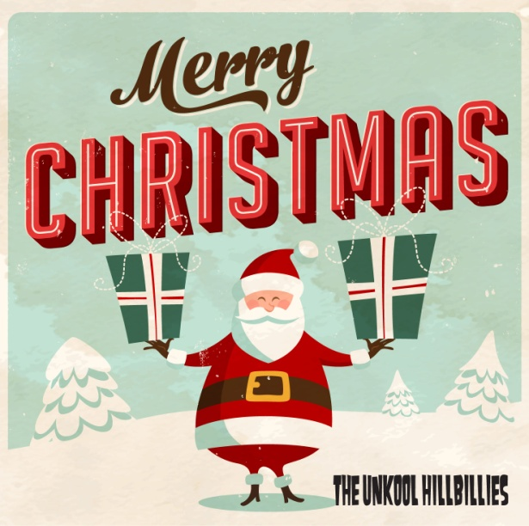
Solid rock’n’roll and Christmas spirit!
The Unkool Hillbillies are now on their 15th year as a touring act. The band has released four albums to today’s date, toured frequently in Europe and in USA. They are, despite the name, not playing ”hillbilly” – but they are, in heart and soul, hillbillies rooted far away from the big city lights – instead the music consist of their renowed blend of rock’n’roll, rock-a-billy and rhythm&blues.
This year they release a Christmas special 10-track album in a limited edition along with a single (Green Christmas / Merry Christmas, Baby) released digitally (Spotify, iTunes etc.) The band sends a Christmas message as well: In hope of future white Christmases, and not so blue ones, let’s all have a green one!

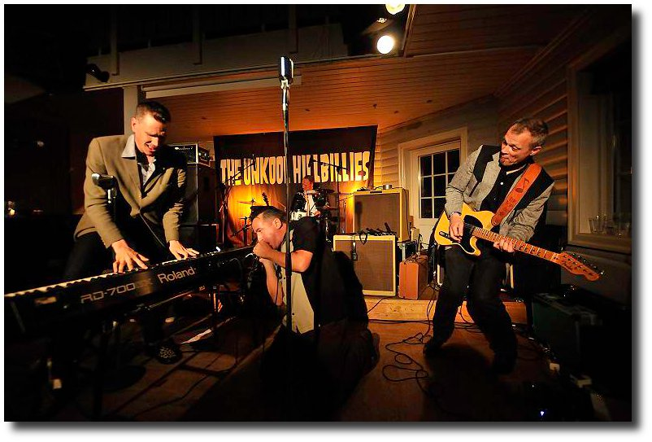

www.unkool.se

